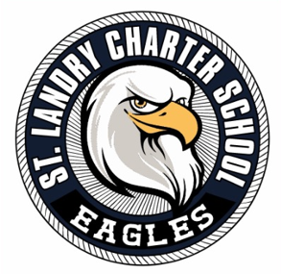
ST. LANDRY CHARTER SCHOOL
Governance Board Agenda
Date: June 9, 2025
Time: 12:00 P.M.
Location: 1203 Burr Street, Opelousas, LA 70570

I. Call to Order
- Meeting formally initiated
II. Pledge of Allegiance
- Recitation of the pledge
III. Moment of Silence
- Observance for reflection
IV. Roll Call
- Attendance confirmation
V. Public Comment
- Open floor for public input
VI. Academic Updates
- Updates from Administration

VII. Finance & Fund Development
- Comments from Chairperson
- Financial Presentation – 4th Sector Solutions
- Approval of Salaries
- Adopt the FY26 Budget
VIII. Governance & Strategic Plan
- Call to Order
- Roll Call
- Updates from Executive Director
- Approval of April’s Board Minutes
- Review & Approval : SLCS Sexual Abuse & Misconduct Prevention Policy ; SLCS Maternity Leave Policy
- Comments from Board President
- Adjournment

