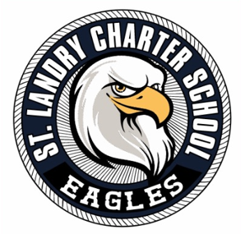
ST. LANDRY CHARTER SCHOOL
Governance Board Agenda
St. Landry Charter School
Board of Directors Meeting Agenda
Thursday, July 17, 2025 • 12:00 p.m.
I. Call to Order
II. Pledge of Allegiance
III. Moment of Silence
IV. Roll Call
V. Public Comment
VI. Meeting of the Whole
(No committee reports will be presented.)
VII. Action Items
- Consideration and approval of the revised Student Handbook
- Consideration and approval of the revised Employee Handbook
- Consideration and approval of the revised Crisis Management Plan
- Consideration and approval of the board meeting minutes from June 2025
- Consideration and approval of the plans and contract for roofing repairs
- Consideration and approval of the contract and plans for the Athletic Building
VIII. Executive Director’s Comments
IX. Board President’s Comments
X. Adjournment

