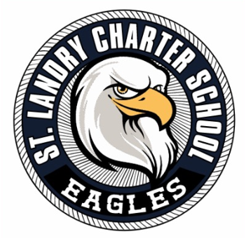
ST. LANDRY CHARTER SCHOOL
Governance Board Agenda
Date: October 27, 2025
Time: 5:30 P.M.
Location: 1203 Burr Street Opelousas, La 70570

- Call to Order
- Pledge of Allegiance
- Moment of Silence
- Roll Call
- Public Comment

Academic Committee
- Academic Update
Presenter: Principal Semien

Finance and Fund Development
- Financial Report and Presentation
Presenter: 4th Sector Solutions

Governance and Strategic Plan
- Approval of September Meeting Minutes
- Approval of Employee Handbook Updates
- Approval of Student Handbook Updates
- Report from the Executive Director
- Board Chair Closing Comments

- Adjournment

