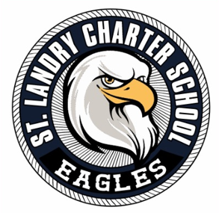
3ST. LANDRY CHARTER SCHOOL
Governance Board Agenda
Date: September 16, 2025
Time: 5:30 P.M.
Location: 1203 Burr Street Opelousas, La 70570

- Call to Order
- Pledge of Allegiance
- Moment of Silence
- Roll Call
- Public Comment
Academic Committee
- Academic updates – Principal Semien
Finance & Fund Development
- Financial Presentation – 4th Sector Solutions (Kevin Cox)
- Recommendation to approve issuance of State Stipends
- Presentation / Approval of Reduction in Force Policy & Proposal
- Revisit prior vote on SLCS Athletic Building Funding
Governance & Strategic Plan
- Approval of August & September Minutes
- Updates from the Executive Director
- Approval to issue state stipends as recommended by the board
- Grant permission to Executive Director to implement Reduction in Force Policy
- Comments from Board Chair
- Adjournment

